Press Release 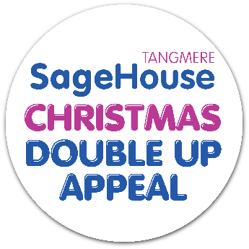

21st November 2023

A £100k Christmas fundraising appeal with a difference –
where One DONATION can have DOUBLE the IMPACT
for carers of people living with dementia and their loved ones.

With dementia numbers on the rise, a West Sussex-based charity, currently the only one of its kind in the country, is appealing for support in helping to expand its vital services and support groups for the carers of people living with dementia.
As an independent charity, Sage House relies entirely on the kind generosity of the public to provide life changing services including emotional, social, legal and financial advice, help to navigate the complex health and social care system, respite care, dementia friendly hairdressing, assisted bathing, wellbeing activities, dementia supporter training and courses for carers all under one roof.

This month, the team at Tangmere’s Sage House is delighted to be able to launch the ONE donation, DOUBLE the Impact campaign. It means that every donation made to Sage House from midday Tuesday 28th November up to and including Tuesday 12th December will be DOUBLED by special match fund champions.

The funding has never been more desperately needed, especially in light of recent research which found that one in two of us will be affected by dementia in our lifetime, either by caring for someone who has the condition, being diagnosed with dementia, or both (Alzheimers Research). Today it is estimated that there are currently 944,000 people living with dementia in the UK. This number is predicted to grow to 1.6 million by 2040 and 1 in 3 of us will be diagnosed with the condition.

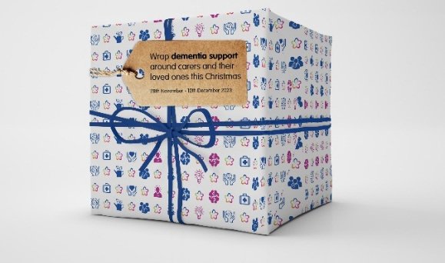
John Stone, from Littlehampton, is sole carer of his wife Jean of 60 years. He said:
“Before Sage House I felt so lonely, really lonely. I don’t know what my life would be without it - I honestly mean that. I can’t recommend Sage House enough when I talk to people. It is a family. We just feel part of the family.”
You can see their story and more on our Christmas Double Up Appeal page here – www.dementiasupport.org.uk/christmas-appeal.
Sally Tabbner, Dementia Support CEO, said: “By doubling all donations, we can get even closer to our £100,000 target and help more people like John and Jean to benefit from our essential dementia support services”.
“Your donation makes it possible for Sage House to deliver essential personalised services to people living with dementia, their loved ones and their carers throughout their whole dementia journey”.

To gift carers and their loved ones the help to live well with dementia this Christmas and have your donation DOUBLED, please visit: www.dementiasupport.org.uk/christmas-appeal or, donations can be accepted by post or in person at Sage House.

If you, or someone you know is affected by dementia, and you would like support or more
information on any of their services offered at Sage House,
please call 01243 888691 or visit www.dementiasupport.org.uk
---
ENDS
---
Notes to Editor:

- Established in 2014, Dementia Support is a charity that has been operational since opening the doors of Sage House in 2018.

- Our vision is “a society where dementia is wholly understood and accepted, enabling people living with dementia to be fully supported throughout the whole of their journey.”

- Our mission is “to deliver seamless and holistic care from a centre of excellence for local people living with dementia. We will work in partnership with the NHS, West Sussex County Council, and other statutory, voluntary, and charitable organisations from within the community to provide personalised services for whoever requires them and whenever they need us”.

- Dementia Support delivers services to people affected by memory loss and dementia through its local dementia hub, Sage House, based in Tangmere, Chichester, West Sussex.

- If you would like to talk to someone about dementia, please call the Wayfinding Team at Sage House on 01243 888691.

Contact Details: For further information please contact Mark Hilder, Individual Giving Fundraising Lead at Sage House at fundraising@dementiasupport.org.uk or on 01243 958460.

